Chapter
Quality Management and International Standards

Discussion Questions
1. Higher quality leads to greater demand, to greater market share, to greater economies of scale. Additionally, higher quality leads to less scrap, rework, and warranty cost, hence to less input required for same output.
2.
Baldrige Award Categories, Items, and Point Values
Categories/Items |  | Point Values
1.0 | Leadership | 120
 | 1.1 Senior Leadership |  | 70
 | 1.2 Governance and Social Responsibilities |  | 50
2.0 | Strategic Planning |  | 85
 | 2.1 Strategy Development |  | 40
 | 2.2 Strategy Deployment |  | 45
3.0 | Customer and Market Focus |  | 85
 | 3.1 Customer and Market Knowledge |  | 40
 | 3.2 Customer Relationships and Satisfaction |  | 45
4.0 | Measurement, Analysis, and Knowledge  Management |  | 90
 | 4.1 Measurement, Analysis, and Improvement of Organizational Performance |  | 45
 | 4.2 Management of Information, Information Technology, and Knowledge |  | 45
5.0 | Workforce Focus |  | 85
 | 5.1 Workforce Engagement |  | 45
 | 5.2 Workforce Environment |  | 40
6.0 | Process Management |  | 85
 | 6.1 Work Systems Design |  | 35
 | 6.2 Work Process Mngt. and Improvement |  | 50
7.0 | Results |  | 450
 | 7.1 Product and Service Outcomes |  | 100
 | 7.2 Customer-Focused Outcomes |  | 70
 | 7.3 Financial and Market Outcomes |  | 70
 | 7.4 Workforce-Focused Outcomes |  |  | 70
 | 7.5 Process Effectiveness Outcomes |  | 70
 | 7.6 Leadership Outcomes |  | 70
Total Points |  |  | 1000
Source: Malcolm Baldrige National Quality Award 2007 Criteria for Performance Excellence, at www.quality.nist.gov.
3. Of Deming’s 14 points, “finding problems” is certainly one of the three. The selection of the other two is not as clear-cut. Many would say “reducing fear” is important, but its purpose is really to find problems. The first point, on getting management to put forth common goals and stick with them—“constancy of purpose”—is our second choice. The third is “methods”—not giving goals
without providing the methods to achieve them.
4. Seven concepts for an effective TQM program: continuous improvement, Six Sigma, employee empowerment, benchmarking, just-in-time, Taguchi concepts, and knowledge of TQM tools. The 14 points were Deming’s way of showing how he implemented TQM.
5. Deming (14 points, leadership and training; good workers cannot overcome bad processes); Crosby (Quality is Free—the cost of poor quality is underestimated); and Juran (top management involvement in quality is vital).
6. The seven tools of TQM are:
- Checksheet
- Scatter diagram
- Histograms
- Pareto charts
- Flow charts
- Cause-and-effect diagrams
- Statistical process control chart
7. If there is fear, people will not bring up problems. If there is no pride in work, there is no motivation. If management does not lead by example, why should employees care?
8. A university can seek to control the quality of its graduates by:
- Setting specific goals for its overall accomplishments
- Employing quality faculty
- Setting appropriate standards (prerequisites, GPA, required credit hours, etc.)
- Employing appropriate evaluation devices (quizzes, examinations, term papers, etc.)
9. Philip B. Crosby believed that quality is free because, on balance, the quality (doing things right the first time) costs only a fraction of the benefits. The cost of poor quality is vastly understated, which makes good quality free.
10. Quality robustness, quality loss function, and target-oriented quality.
11. A Pareto chart’s purpose is to identify the critical problems and separate them from the less important ones.
12. Ishikawa “causes”: material, machinery/equipment, methods, and manpower.
13. Inspect at your supplier’s plant while the supplier is producing, inspect at your facility upon receipt of goods from your supplier, inspect before costly or irreversible processes, inspect during the step-by-step production process, inspect when production or service is complete, and inspect before delivery from your facility; all work well in manufacturing. Inspection at point of customer contact does not.
14. The design and delivery of service can make a difference on the tangible components of service, containing the determinants of service quality in the process design, managing expectations, and having alternate plans for exceptions.
■ Is th# bathroom tub and show#r spotl#ssly cl#an?
■ How many minut#s do#s it tak# to g#t coff## aft#r th#
gu#st sits down for br#akfast?
■ Did th# wait#r mak# #y# contact?
■ W#r# Minibar charg#s post#d corr#ctly on th# bill?.
#stablish#d standards, aggr#ssiv# training, and insp#ctions ar# part of th# TQM #ffort at th#s# hot#ls. Quality do#s not happ#n by accid#nt.
15. Source inspection: consistent with the concept of employee empowerment, individual employees self-check their work and verify the work of the employee preceding them.
16. According to Berry, Zeithaml, and Parasuraman, the 10 determinants of service quality are:
- Reliability
- Responsiveness
- Competence
- Access
- Courtesy
- Communication
- Credibility
- Security
- Understanding/knowing the customer
- Tangibles
17. If one adopts a definition of quality based upon “satisfying stated or implied needs,” it is difficult to imagine any product that would not be required to be of high quality.
18. The formula: L = D2C portrays a loss that increases at an increasing rate the further we get from the desired target.
19. Counting the number of E’s in the OM in Action box.

RICH#Y INT#RNATIONAL’S SPI#S
How do luxury hot#ls maintain quality? Th#y insp#ct. But wh#n th# product is on#-on-on# s#rvic#, larg#ly d#p#nd#nt on p#rsonal b#havior, how do you insp#ct? You hir# spi#s!
Rich#y Int#rnational is th# spy. Pr#f#rr#d Hot#ls and R#sorts Worldwid# and Int#rcontin#ntal Hot#ls hav# both hir#d Rich#y to do quality #valuations via spying. Rich#y #mploy##s posing as custom#rs p#rform th# insp#ctions. How#v#r, #v#n th#n manag#m#nt must hav# #stablish#d what th# custom#r #xp#cts and sp#cific s#rvic#s that yi#ld custom#r satisfaction. Only th#n do manag#rs know wh#r# and how to insp#ct. Aggr#ssiv# training and obj#ctiv# insp#ctions r#inforc# b#havior that will m##t thos# custom#r #xp#ctations.
Th# hot#ls us# Rich#y’s und#rcov#r insp#ctors to #nsur# p#rformanc# to #xacting standards. Th# hot#ls do not know wh#n th# #valuators will arriv#. Nor what alias#s th#y will us#. Ov#r 50 diff#r#nt standards ar# #valuat#d b#for# th# insp#ctors #v#n ch#ck-in at a luxury hot#l. Ov#r th# n#xt 24 hours, using ch#ck lists, tap# r#cordings, and photos, writt#n r#ports ar# pr#par#d. Th# r#ports includ# #valuation of standards such as:
■ Do#s th# doorman gr##t #ach gu#st in l#ss than 30
s#conds?
■ Do#s th# front d#sk cl#rk us# th# gu#st’s nam# during
ch#ck-in?
There are 189 total e’s, each identified by a # sign: 3 are in the title, 18 in the 1st paragraph, 62 in the 2nd, 50 in the 3rd, and 56 in the list and last paragraph.
Ethical Dilemma
The ethics issue here is certainly less clear than some of the equally prominant situations that have arisen in the past few decades. Some of these are
- The asbestos litigation of 2003 cost over $200 billion and sent nine defendants out of business.
- Firestone discounted sales of defective tires to the Southeast U.S. and recalls of 13.5 million tires cost $200 million.
- A.H. Robins’s Dalkon Shield intrauterine device (IUD) resulted in 18 U.S. deaths and 11,000 lawsuits. It forced
Robins into Chapter 11 bankruptcy reorganization. Searles’s similar product, the Copper 7, was pulled from the U.S. market, then sold overseas.
Is McDonald’s at fault? Students can do a Web search and find numerous articles on these lawsuits. It appears that the company should have had a presumption of danger to customers from the scalding hot office. However, “good” coffee is apparently prepared with very hot water.
See the text discussion regarding perspective of quality: User based (quality is in the eyes of the beholder); manufacturing based (quality conforms to standards); and product based (quality is precise and measurable).
Active Model Exercise*
Active Model 6.1: Pareto Charts
1. What percentage of overall defects do the room service complaints account for?
72%
2. If we could reduce the room service complaints in half how does this affect the chart?
The bar for room service is cut in half. The cumulative curve begins lower and has a steeper build.
End-of-Chapter Problems
*This Active Model can be found on our Companion Web site, www.pearsonglobaleditions.com/heizer.

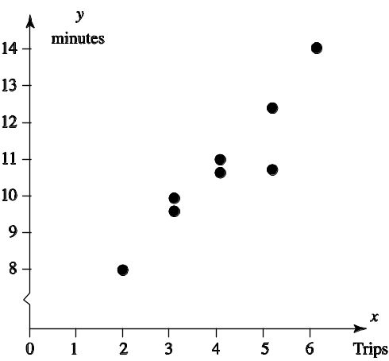
6.1 (a)
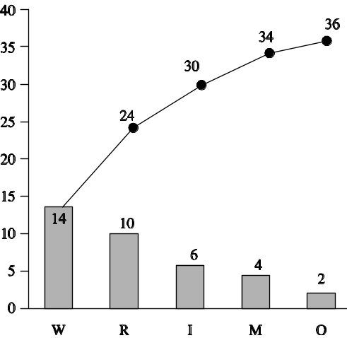
(b) 39% of complaints, W, are demeaning toward women.
6.2 The idea is to get students to seek out information via a scatter diagram. For instance, a scatter diagram with pages of a major city newspaper on the y-axis and day of the week on the x-axis would show clusters of low pages on Saturday and probably Monday and high pages on Sunday.
6.3 From these statistics, it would appear that a student could argue that some of the cause of the poor grade was due to factors primarily outside his/her control . . . and poor planning.

Reason for Poor Grade | Frequency | %
Difficulty understanding material | 25 | 37
Insufficient time to complete | 15 | 22
Distractions in exam room | 9 | 13
Late arrival to exam | 7 | 10
Felt ill during exam | 4 | 6
Forgot exam was scheduled | 3 | 4
Insufficient preparation time | 2 | 3
Studied wrong material | 2 | 3
Calculator batteries died during exam | 1 | 1

6.4 Individual response, but we should have frequency on the
y-axis and time, perhaps in 15-second intervals at most fast-food restaurants, on the x-axis.
6.5 (a)
(b) This is a scatter diagram.

6.6 Partial Flowchart for Planning a Party
There are many forms and symbols used in flowcharts. One
approach follows:

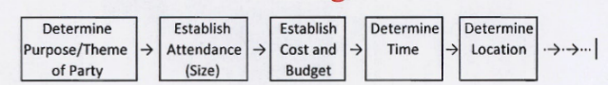

Another approach is a work breakdown structure similar to that shown in Chapter 3 (see Figure 3.3). Also see chapter 6, Figure 6.6e.
6.7
(a) A possible list might include:
Running light
Speeding
No turn signal
Failure to yield on left turn
No stop when turning right on red light
Blocking intersection on red
Honking horn when light turns green
Not observing light when it turns green
Turning from wrong lane
Appear to go through light but stop suddenly
Other
Check sheet might look like the following:
The frequency counts for this set of observations is shown on the right. The check sheet can be used to discuss the differences in driving habits at different times of the day.
Location: 2nd |  | Time of Day
and Forrester
Poor Driving  Habit | 7:00–7:20 a.m. | 10:00–10:20 a.m. | 5:00–5:20 p.m. | 7:30–7:50 p.m. | Total
Running light | √ √ √ √ √ | √ √ √ | √ √ √ √ √ | √ | 14
Speeding | √ √ √ √ | √ √ | √ √ √ √ √ √ √ |  | 13
No turn signal | √ √ √ | √ | √ √ √ | √ | 8
Failure to yield on | √ √ | √ √ √ | √ √ | √ | 8
left turn
No stop when | √ √ √ |  | √ √ √ √ | √ | 8
turning right on red
light
Blocking | √ √ √ √ |  | √ √ √ √ √ √ |  | 10
intersection on red
Honking horn | √ √ √ √ √ | √√ | √ √ √ √ | √ | 12
when light turns
green
Not observing light | √ | √ √ | √ | √ √ | 6
when it turns green
Turning from |  | √ |  | √ | 2
wrong lane
Appear to go | √ √ |  | √ | √ | 4
through light but
stop suddenly
Other | √ √ √ √ √ √ | √ | √ √ √ | √ | 11

Sorted Frequency Table
Poor Driving Habit | Frequency
Running light | 14
Speeding | 13
Honking horn when light turns green | 12
Other | 11
Blocking intersection on red | 10
Failure to yield on left turn | 8
No stop when turning right on red light | 8
No turn signal | 8
Not observing light when it turns green | 6
Appear to go through light but stop suddenly | 4
Turning from wrong lane | 2

(b) The check sheet results can be sorted into a descending frequency table.

A Pareto chart like that shown below can illustrate the major habits that dominate the behavior. Note: A classic
Pareto chart would include a cumulative probability line.

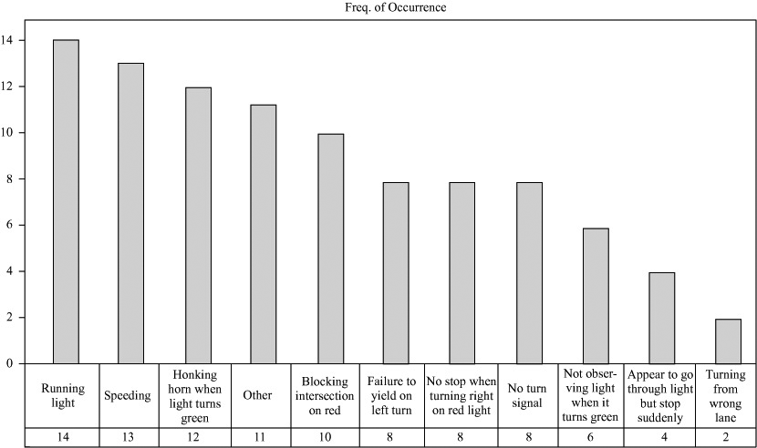

6.8 Cause-and-effect diagram (also known as a fish-bone chart or an Ishikawa diagram) for a dissatisfied
airline customer.

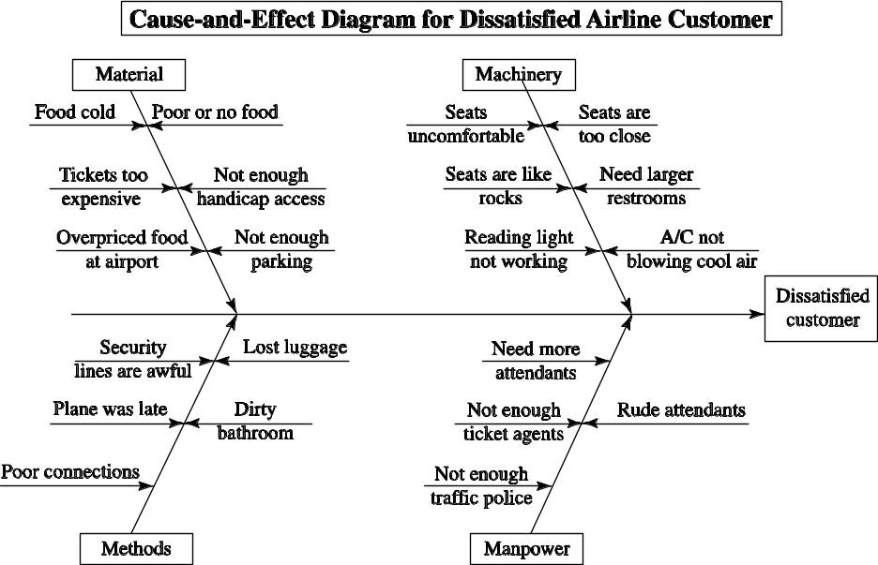

Freq. of Occurrence

6.9 Depending on the type of student body, the response could
vary. A typical chart might look like the following:
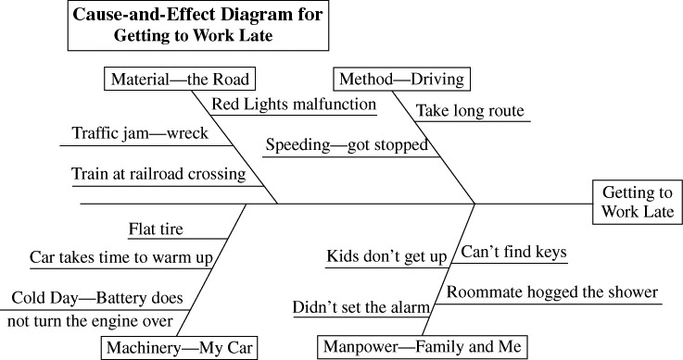
6.10 Student answers will depend upon how broadly they define “registration.” (Is fee payment included? Is academic advising included?) Manpower issues might include rudeness, lateness, missing appointments, incompetence. Methods issues might include excessive red tape, tasks that don’t make sense, rules that contradict one another, rules that are impossible to interpret or implement, low enrollment caps on classes, administrators that are inflexible with exceptions. Machinery issues might include registration computers that are slow or broken, printer issues, etc. Material issues might include too few classes at selected hours, forms that can’t be found, etc.
6.11 A potential chart might look like that shown below. Each student will brainstorm different bones in the chart, depending on the particular experiences and systems of the situation.
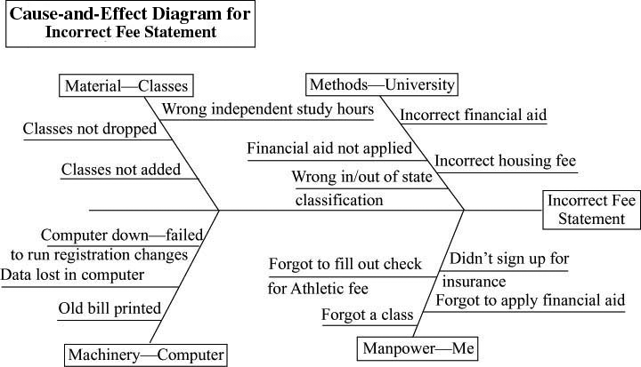

6.13
6.12

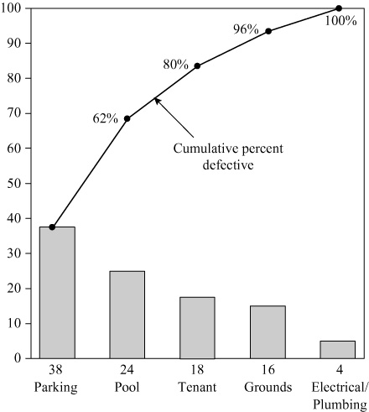

Recommendation: Start improvement by focusing on the high-frequency items (i.e. parking, pool, etc.)
(a)
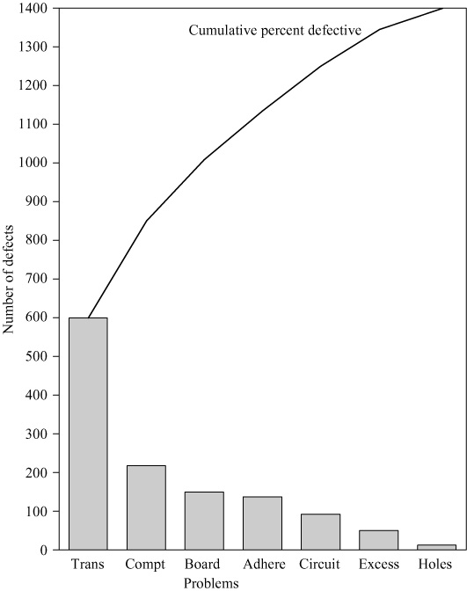
(b) Conclusion: Most of the errors are the result of misplaced transistors.
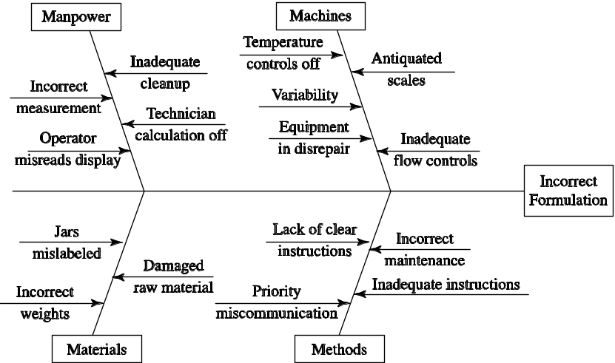
6.14

6.15 Individual responses will vary.
6.16 (a) The scatter diagram shows a strong positive relationship

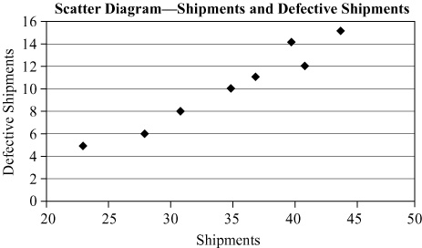
(b) The scatter diagram will resemble the chart below:
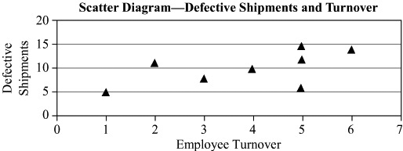
There is an obvious relationship between turnover and quality as shown in this scatter diagram.

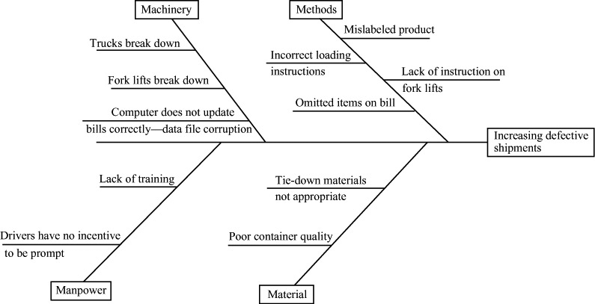

(c) The Pareto chart is:
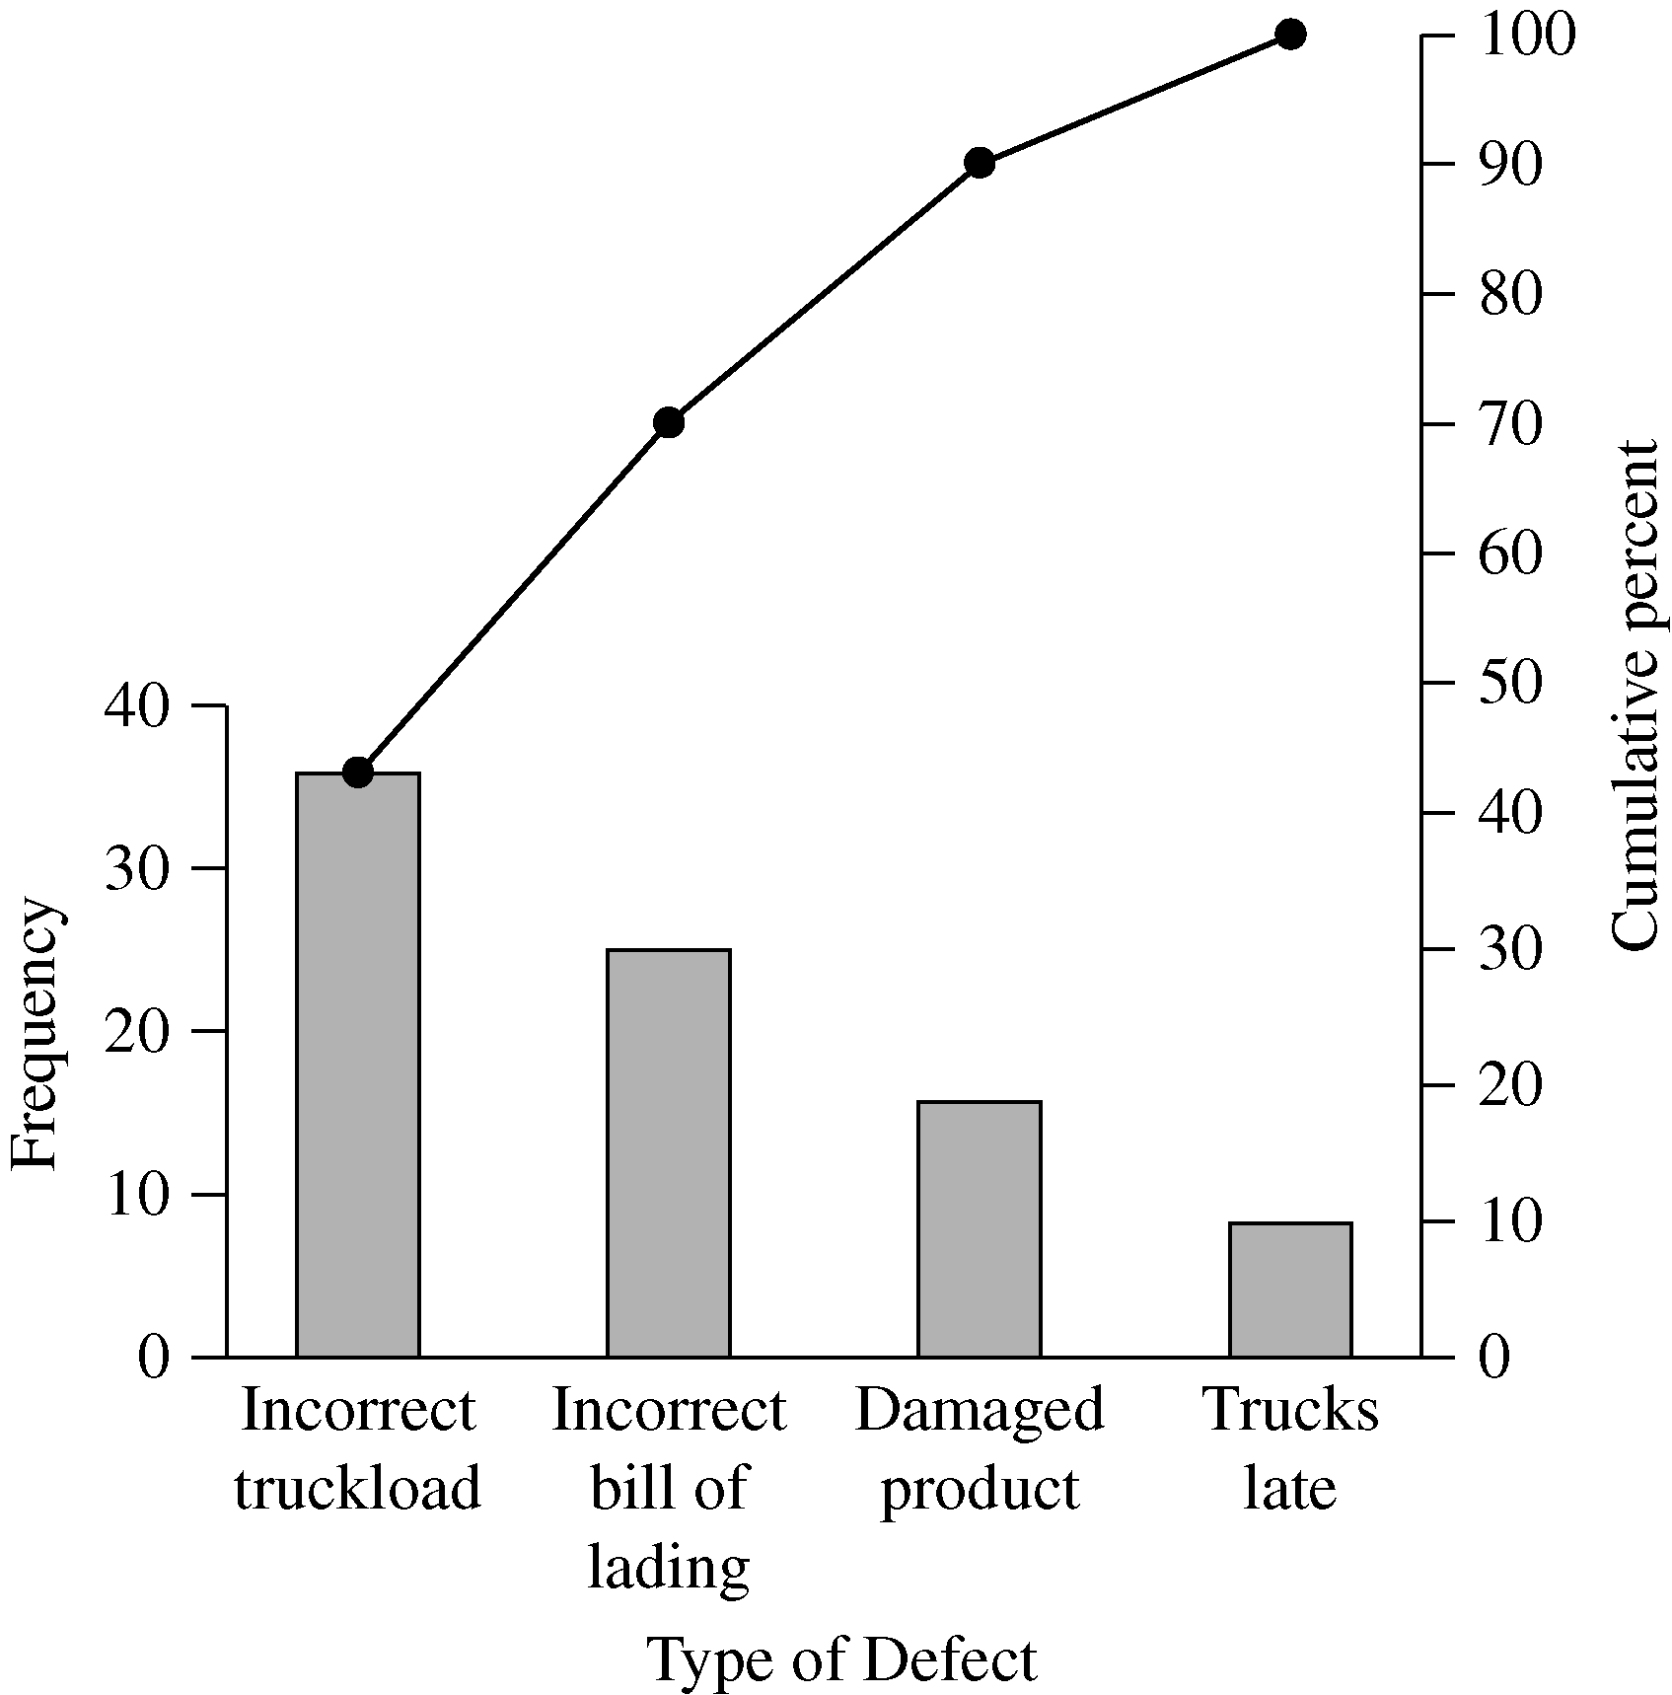
(d) This is more appropriate for an in-class or group exercise where students may brainstorm for ideas. The possible causes should go on the four main bones. An example:
6.17 Conversion of data into percentages in the first step:
Cramped seats =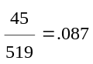
Cost = 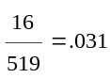
Dislike/fear flying =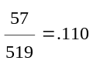
Security =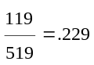
Poor service = 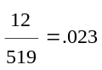
Connections =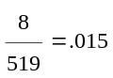
Overcrowded planes =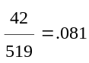
Late planes/waits =
Food =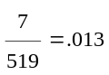
Luggage =
Other =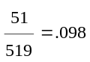
Note that each person had only one complaint.
- The above dislikes total to .81 or 81%. So 19% stated no dislikes (this represents 98 responses).
[So 519 – 421 = 98/519 = 19%].
- Pareto Chart

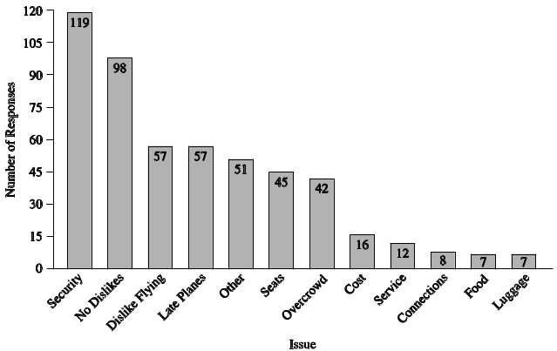

*Note to instructor: To broaden the selection of problems, these 4 problems are also available to you and your students.
- Fishbone. Note that not at all of these are easily assigned to a specific M. “Fear or dislike of flying” may be
Machinery, Material, Manpower, or Methods (the way the passenger is treated).
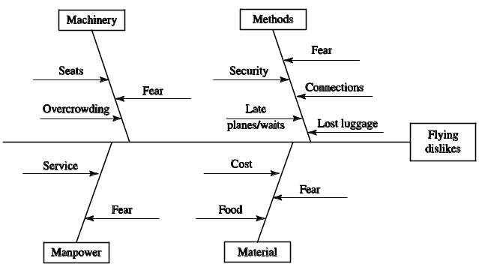
(d) Start with most frequent complaints from the Pareto chart over which you have control as the manager of the airline: late planes, cramped seats, and overcrowding. These comprise about 28% of the dislikes. Security is mostly outside an airline’s control.
Additional Homework Problems*
These problems appear on our Web site, at www.pearsonglobaleditions.com/myomlab.
6.18 The idea is to take six shirts or blouses and inspect them for poor stitching, misaligned seams, errors in buttons or buttonholes, collar alignment, etc., and indicate the problems on a shirt template.
6.19 Individual response, but any retail situation should provide a rich set of examples: average service time in a bank, uniform inspection in a restaurant or band, guest response form in a hotel, faculty evaluation form in a college, etc.
6.20
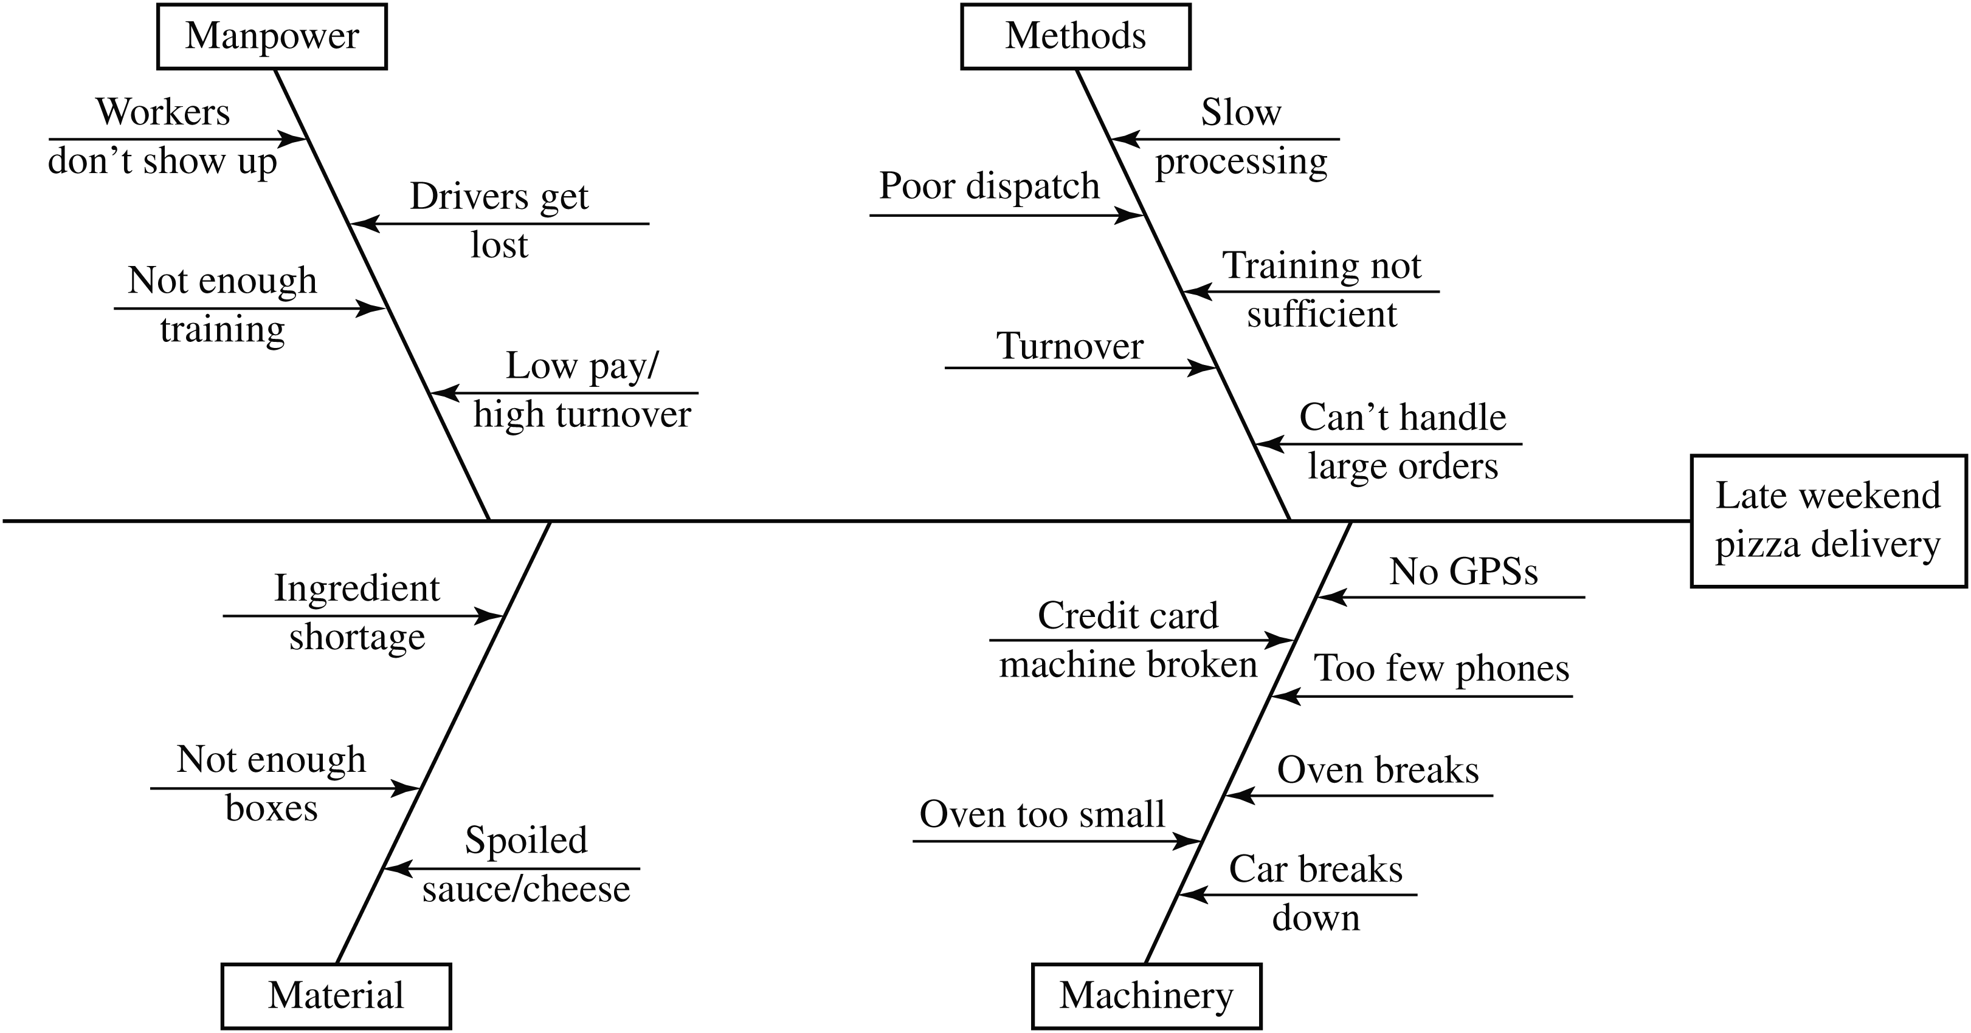
6.21
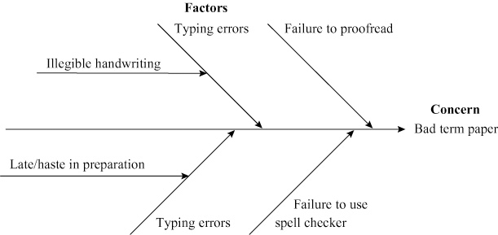
Case Study
SOUTHWESTERN UNIVERSITY: C
1. There are lots of ways to analyze this data. We suggest getting the student to begin by considering the tools of TQM and go from there. Here we have weighted these survey data (from Table 6.7) with 4 for good and 0 for poor in Table 1 below, and then ranked them. This approach yields the data in descending order (Poor to Good) in Table 2. Then we take the open-ended questions and look at both the positive and negative responses (Table 3). Then we rank these in descending order (most negative to least negative).

Table 2
Items in Weighted Descending Order
Speed of Service | 1.66 | Poor
Seating | 2.14
Printed Program | 2.34
Concession Prices | 2.34
Traffic | 2.41
Season Ticket Plans | 2.76
Parking | 3.08
Ticket Pricing | 3.12
Entertainment | 3.23
Food Selection | 3.44 | Good

Table 3: Open-ended Comments
 |  | Results by Topic
Negative | Entertainment | Positive | Negative | Facilities | Positive
 | Entertainment | 8 | 14 | Seats | —
3 | Student Behavior |  | 9 | Parking | —
2 | Crowded |  | 5 | Need Sky Boxes | —
1 | Cheerleaders |  | 5 | Other | 1
1 | Programs |  | 2 | Bathroom | —
 | Band | 1 | 1 | Traffic | —
 | Coach | 3
 |  |  |  | Food
 |  |  | 3 | Access/Variety | —
 |  |  | 1 | Quality | 1
 |  |  | 1 | Price | —

Table 1: Survey Data, with no. of responses × weight calculated
 | Weights |  |  |  |  |  | Total/250  (Average)
 | 4 | 3 | 2 | 1 | 0 | Total | Total/250  (Average)
Parking | 360 | 315 | 90 | 5 | 0 | 770 | 3.08
Entertainment | 640 | 105 | 52 | 10 | 0 | 807 | 3.23
Traffic | 200 | 255 | 96 | 52 | 0 | 603 | 2.41
Printed Program | 264 | 102 | 196 | 22 | 0 | 584 | 2.34
Seating | 180 | 90 | 230 | 35 | 0 | 535 | 2.14
Ticket Pricing | 420 | 312 | 32 | 15 | 0 | 779 | 3.12
Season Ticket Plans | 300 | 240 | 108 | 41 | 0 | 689 | 2.76
Food Selection | 620 | 180 | 48 | 11 | 0 | 859 | 3.44
Concession Prices | 64 | 348 | 116 | 58 | 0 | 586 | 2.34
Speed of Service | 140 | 135 | 92 | 48 | 0 | 415 | 1.66

Table 4
Results in Descending Order
(Most negative to least negative)
Seats | 14
Parking | 9
Need Sky Boxes | 5
Other Facilities | 5
Student Behavior | 3
Access/Variety | 3
Crowded | 2
Bathrooms | 2
Cheerleaders | 1
Programs | 1
Traffic | 1
Quality | 1
Price | 1
Band
Coach
Figure 1: Cause-and-Effect Diagram for s.w.u
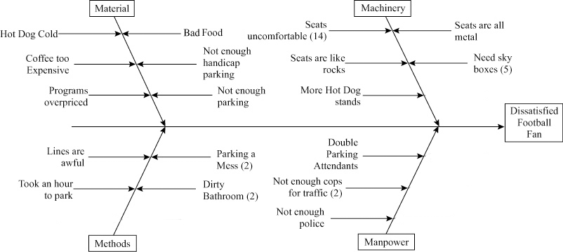

Note how the survey results differ between the survey and open-ended comments. Parking, for instance, comes in second on the open-ended comments, but with the weighting scheme it is near the bottom (Table 2). Bathrooms were not included on the survey questions, but show up on the open-ended comments. Different methodologies often yield different results. Fishbone analysis appears in Figure 1.

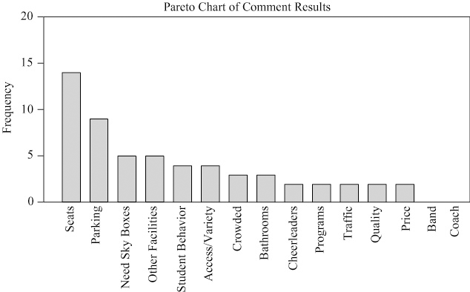

2. The survey could have been segmented by faculty, alumni, guests, and students for an added perspective on quality.
3. The next step is to improve quality by beginning improvement with the high-frequency item on the left of the Pareto chart for the open-ended negative responses (see Figure 2).

Figure 2: Pareto Chart Results for s.w.u.

Video Case Studies
the Culture of Quality at Arnold Palmer Hospital
1
The Arnold Palmer Hospital (APH) video for this case (10 minutes) is available from Prentice Hall, as well as on myomlab.com. Also note that the Global Company Profile that opens this chapter highlights additional issues of quality related to APH.
1. Why is it important for APH to get the patient’s assessment of health care quality? Does the patient have the expertise to judge the health care she receives?
The patient’s assessment of health care quality may drive where the patient goes the next time services are needed. Patient complaints may drive an entire medical practice (for example, a group of 20 OB/GYNs) to send all their patients to a competing hospital. Patients cannot accurately judge all aspects of their medical care, or the care of their child, but they can certainly judge cleanliness, comfort, response times, food, appearances of competence, staffing shortages, politeness, billing errors, bed wait times, etc.
2. How would you build a culture of quality in an organization including APH?
To build a culture of quality in a hospital you need (see Figure 6.2 for a model to build on in class):
Organizational Practice:
- Leadership: Top down support for a total quality management plan.
- Staff support: Good hiring policies that only select the best skilled, warmest, most caring, reliable staff.
- A quality plan that is part of the overall strategic plan for the hospital.

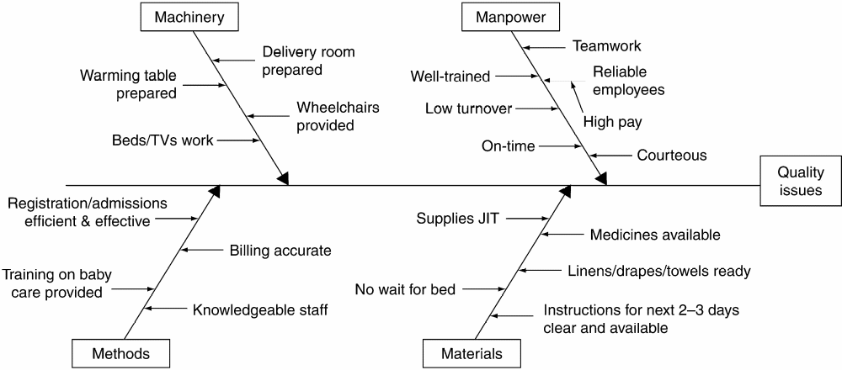

Quality Principles:

- Quality standards that can be published, measured, and compared.
- Customer focus: Procedures to review patient quality care.
- TQM tools techniques that foster quality;
Measurements for the cost of quality;
Plans for dealing with safety and liability problems so they are studied and not allowed to repeat.
Process controls for such areas as lab tests and pharmacy prescription errors.
Effective supplier evaluation and development.
JIT suppliers.
Employee fulfillment:
- Employee quality circles and programs.
- Quality improvement teams that cover all functional areas.
- Empowered employees
3. What techniques does APH practice in its drive for quality and continuous improvement?
- uses benchmarking very effectively.
- employs an executive “dashboard” scoreboard to keep track of major indices of quality.
- a 24-hour hotline system for patients to reach administrators to report problems.
- carefully selects and trains its employees and imbues them with the hospital’s quality credo.
- empowers employees at all levels to deal with problems of quality immediately (providing up to $200 in gifts to
satisfy patients/customers).
- makes extensive use of the tools of quality described in this chapter, especially Pareto and process charts.
4. Develop a fishbone diagram illustrating the quality variables for a patient who just gave birth at APH.
QUALITY AT THE RITZ-CARLTON HOTEL
2
The Ritz-Carlton video (7 minutes) is available from Prentice Hall and is also on myomlab.com.
As an introductory note, students may appreciate the following.
The cost of poor service is tremendous, and the cost is magnified by the negative impact unsatisfied customers have on prospective customers, as noted in the following example from Southwest Airlines.
How important is every Customer to our future? Our Finance Department reports that our break-even Customer per flight in 1994 was 74.5, which means that, on average, only when Customer #75 came on board did a flight become profitable.
Aside from that statistical data, let me share with you a down-to-earth formula devised by our Dallas chief pilot, Ken Gile. It utilizes our annual profit and total flights flown to clearly illustrate how vital each Customer is to our profitability and our very existence.
When you divide our 1994 annual profit by total flights flown, you get profit per flight
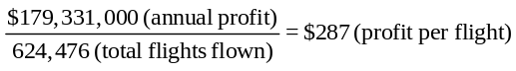
Then, divide per flight by Southwestern’s system-wide aver-age one-way fare of $58:
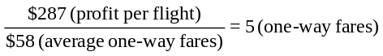
The bottom line, only five Customers per flight accounted for our total 1994 profit!
Source: Freiburg, Kevin, and Jackie Freiburg, “Nuts! Southwest Airlines’ Crazy Recipe for Business and Personal Success,” Bard Press, 1996, p. 120.
1. The Ritz-Carlton can monitor quality in the short run
by customer feedback. Questionnaires in the room, follow-up letters and phone calls by independent services, tracking complaints, and ultimately by occupancy rates. There are, of course, objective measures in many aspects of hotel operations. These include room cleanliness, quality of food, accuracy of billing, and reservations.
2. For companies that expect quality to be more than a slogan we suggest they follow the ideas of the text:
- A philosophy of continuous improvement
- Employee empowerment
- Benchmarking
- Just-in-time (JIT)
- Knowledge of tools
3. The lack of quality will manifest itself in room rate reductions, extra supervision, complaints, and ultimately lower occupancy.
4. Great question for class discussion: control charts can be
used for tracking customer complaints, Pareto diagrams to find where to focus improvement efforts, cause-and-effect diagrams
to analyze the source of causes, in the kitchen, reservations,
billing, etc.
5. Some nonfinancial measures of quality might include those noted above: room service, food quality, customer complaints, etc.

Additional Case Study*
WESTOVER ELECTRICAL, INC.
Note: This is a case that can be used as an introduction to TQM tools or after the tools are introduced as a learning tool demon-strating how Pareto analysis, control charts, and cause-and-effect charts are used.

Pareto Analysis by Winder
Defect | Combined | W1 | W2 | W3
Abraded Wire | 81 | 3 | 2 | 76
Failed Electrical Test | 66 | 1 | 3 | 62
Broken Lead | 66 | 62 | 2 | 2
Wrong Wire | 22 | 2 | 19 | 1
Broken Winder | 10 | 3 | 7 | 0
Tow Wire | 9 | 5 | 4 | 0
Wrong Core | 7 | 1 | 5 | 1
Totals | 261 | 77 | 42 | 142
Analysis by Winder:
- Broken leads is a Winder 1 problem (94% of all broken leads and 81% of Winder 1 problems)
- Wrong wire is a Winder 2 problem (86% of all wrong wires and 45% of Winder 2 problems)
- Abraded wire and failed electrical test appear to be correlated and to be a Winder 3 problem (54% and 44% of all Winder 3 problems, respectively).
Analysis by Time:
- Wrong wire and wrong core rejects occurred mainly at first of month on Winder 2 (17/19 before 10th).
Control Charts:
- Could use p chart if it is assumed that any one defect results in a defective unit, and there is no more than one defect per inspected unit. Could use c chart to plot number of defects per sample. Must do separate chart for each Winder.
Cause-and-Effect Chart:
- At least mention.
Recommendations:
- Find cause for abraded wire and failed electrical test on Winder #3. Could same cause create both problems? Could eliminate 56% of all Winder rejects and 97% of Winder #3 rejects.
- Find cause for broken leads on Winder #1. Could eliminate 81% of Winder #1 rejects and 25% of all rejects.
- Find cause for wrong wire and wrong core early in month
on Winder #2. Could it be a new operator who made fewer mistakes as he/she gained experience?

*Solution to the case appears on our Companion Web site, at
www.pearsonglobaleditions.com/heizer, as well as
on www.pearsonglobaleditions.com/myomlab

